Kush Patel – n01350301

1. 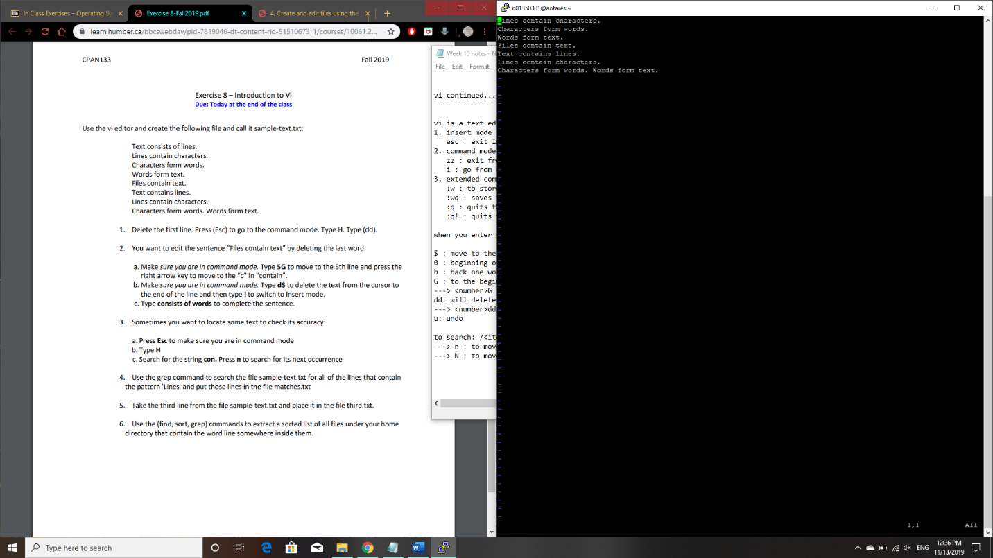
2. 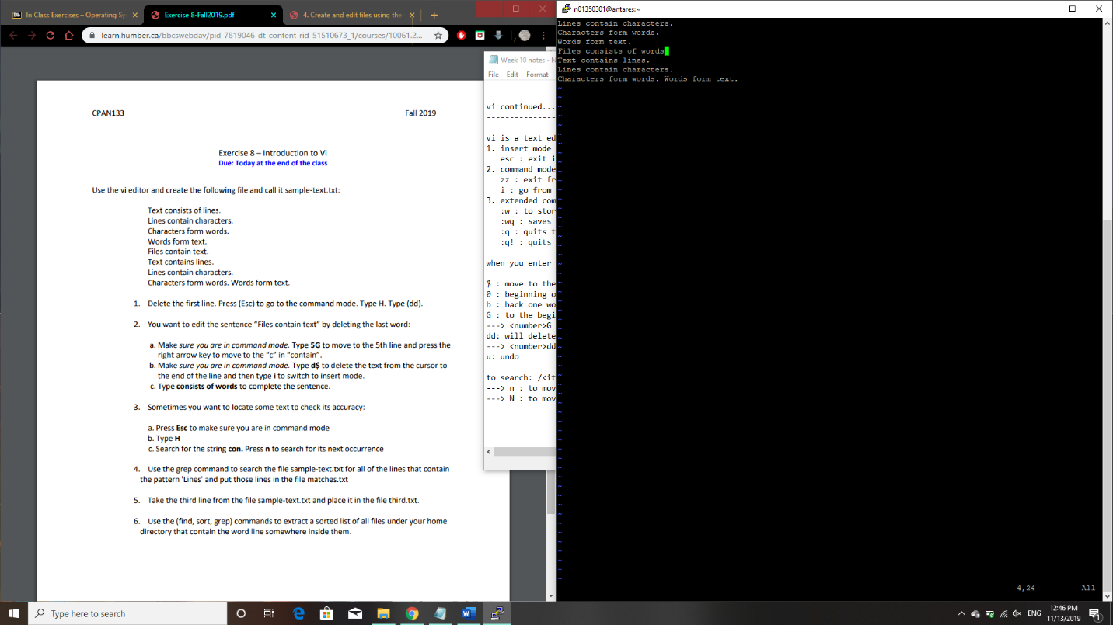
3. 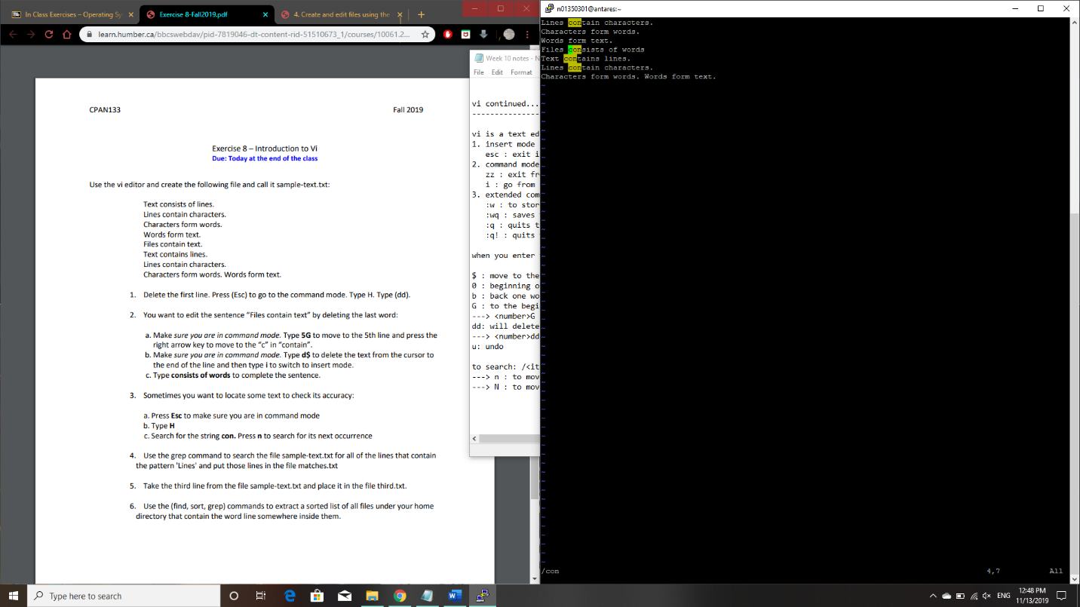
4. grep Lines sample-text.txt > matches.txt
5. cat sample-text.txt | head -3 | tail -1 | cat > third.txt
6. find ~ \* | grep line | sort